NITTE MEENAKSHI INSTITUTE OF TECHNOLOGY
(AN AUTONOMOUS INSTITUTION, AFFILIATED TO VISVESVARAYA TECHNOLOGICAL UNIVERSITY, BELGAUM, APPROVED BY AICTE & GOVT.OF KARNATAKA

PHASE-II REPORT
on
PROJECT TITLE
Submitted in partial fulfilment of the requirement for the award of Degree of
Bachelor of Engineering
in
Computer Science and Engineering
Submitted by:
NAME1  NAME2  NAME3  NAME4 | USN1  USN2  USN3  USN4
Under the Guidance of
GUIDE NAME
DESIGNATION, Dept. of CS&E, NMIT


Department of Computer Science and Engineering
(Accredited by NBA Tier-1)
2021-22
NITTE MEENAKSHI INSTITUTE OF TECHNOLOGY
(AN AUTONOMOUS INSTITUTION, AFFILIATED TO VISVESVARAYA TECHNOLOGICAL UNIVERSITY, BELGAUM
, APPROVED BY AICTE & GOVT.OF KARNATAKA)
Department of Computer Science and Engineering
(Accredited by NBA Tier-1)

CERTIFICATE
This is to certify that the Phase 2 Report on Project Title is an authentic work carried out by NAME1 (USN1), NAME2 (USN2), NAME3 (USN3) and NAME4 (USN4) bonafide students of Nitte Meenakshi Institute of Technology, Bangalore in partial fulfilment for the award of the degree of Bachelor of Engineering in COMPUTER SCIENCE AND ENGINEERING of Visvesvaraya Technological University, Belagavi during the academic year 2021-2022. It is certified that all corrections and suggestions indicated during the internal assessment has been incorporated in the report.
Internal Guide |  | Signature of the HOD |  | Signature of Principal
NAME  Designation, Dept. CSE,  NMIT Bangalore |  | Dr. Saroja Devi.H  Professor & Head, Dept. CSE, NMIT Bangalore |  | Dr. H. C. Nagaraj  Principal,  NMIT, Bangalore
 | Signature of Examiners

DECLARATION
We are hereby declare that
(i) The project work is our original work
(ii) This Project work has not been submitted for the award of any degree or examination at any other university/College/Institute.
(iii) This Project Work does not contain other persons’ data, pictures, graphs or other information, unless specifically acknowledged as being sourced from other persons.
(iv) This Project Work does not contain other persons’ writing, unless specifically acknowledged as being sourced from other researchers. Where other written sources have been quoted, then:
a) their words have been re-written but the general information attributed to them has been referenced;
b) where their exact words have been used, their writing has been placed inside quotation marks, and referenced.
(v) This Project Work does not contain text, graphics or tables copied and pasted from the Internet, unless specifically acknowledged, and the source being detailed in the thesis and in the References sections.

NAME | USN | Signature

Date:
ACKNOWLEDGEMENT

The satisfaction and euphoria that accompany the successful completion of any task would be incomplete without the mention of the people who made it possible, whose constant guidance and encouragement crowned our effort with success. I express my sincere gratitude to our Principal Dr. H. C. Nagaraj, Nitte Meenakshi Institute of Technology for providing facilities.

We wish to thank our HoD, Dr. Saroja Devi H for the excellent environment created to further educational growth in our college. We also thank him for the invaluable guidance provided which has helped in the creation of a better project.

I hereby like to thank our Guide Name, Designation, Department of Computer Science & Engineering on his/her periodic inspection, time to time evaluation of the project and help to bring the project to the present form.

Thanks to our Departmental Project coordinators. We also thank all our friends, teaching and non-teaching staff at NMIT, Bangalore, for all the direct and indirect help provided in the completion of the project.

NAME | USN | Signature

Date:

ABSTRACT

Drowsiness at the wheel is a major problem for traffic road safety. A drowsy driver suffers from decreased vigilance, increased reaction time and degraded decision-making ability, all of which have a huge impact on the driving performance. A driver monitoring system that warns the driver of his or her critical drowsiness state is a worthwhile contribution to traffic road safety. A drowsy driver typically exhibits some observable behaviours, such as eye blinking and head movements, that can be tracked using a camera. In this study, we analyse the potential of eye closure and head rotation signals, provided by a driver camera, to classify the driver’s drowsiness state using logistic regression models. This analysis is based on a large dataset collected from 71 subjects in driving simulator experiments. A reliable and independent reference for drowsiness, however, is required in order to perform this analysis. For this purpose, we devise a methodology that merges several drowsiness monitoring approaches to construct a reliable reference for drowsiness. Furthermore, we describe our approach to extract eye blink and head rotation features. Ultimately, we design logistic regression classifiers and combine them using the one-vs-one binarization technique. Our approach would achieve a high accuracy of 80% plus.
GUIDELINES FOR REPORT WRITING

CONTENTS

Sr. No. | Title | Page No.
1 | PREAMBLE | 1
2 | ORGANISATION OF THE REPORT | 1
 | 2.1. Sequence of Contents: | 1
3 | PRELIMINARIES | 1
 | 3.1. Title Page: | 1
 | 3.2. Abstract: | 2
 | 3.3 Certificate and Declaration | 2
 | 3.4 Acknowledgement | 2
 | 3.5 Table of Contents (ToC) | 2
 | 3.6 List of of Figures and Tables | 2
 | 3.7 Nomenclature | 3
 | 3.8 Numbering of Report | 3
4 | The Chapters | 3
 | 4.1 General Guidelines | 3
 | 4.2 Introduction | 3
 | 4.3 Literature Survey  4.5 System requirements specifications  4.6 Design  4.7 Implementation | 4  5  6  7

CHAPTER 1: INTRODUCTION
  - Background
In recent years, an increase in the demand for modern transportation necessitates a faster car-parc growth. At present, the automobile is an essential mode of transportation for people. In 2017, a total of 97 million vehicles were sold globally, which was 0.3% more than that in 2016. In 2018, the global total estimation of the number of vehicles being used was more than 1 billion. Although the automobile has changed people’s lifestyle and improved the convenience of conducting daily activities, it is also associated with numerous negative effects, such as traffic accidents. A report by the National Highway Traffic Safety Administration showed that a total of 7,277,000 traffic accidents occurred in 2016, resulting in 37,461 deaths and 3,144,000 injuries. In these accidents, most of the accidents happened because of driver’s engagement in other activity like use of mobile phone, drinking water etc. while driving. Thus, careless and reckless as driving is a significant and latent danger in traffic accidents. In recent years, the driver-drowsiness-detection system has become a hot research topic.
Most accidents occur due to the driver being involved in the following 7 activities,
Using in vehicle radio device, texting, answering the mobile phone, drinking or eating, reaching behind, face make up or hair adjusting, one handed driving. These distractions can be briefly branched into the three following major types,
Ocular
[1] Distraction of sight from road.
[2] Physical - Assertion hands from the steering.
[3] Intellectual - Lack of concentration while driving.

A low - cost camera is used to collect experimental images, using naturalistic data from drivers. Then, segmentation of raw images is done to remove background and noise from the image and extract the body of the driver alone using the Gaussian mixture model, before training the activity recognition Convolutional Neural Network model.

BENEFITS:
The detected driver’s behavior is used to alert the driver. The system also automatically turns on the hazard lights and very slowly reduces the speed of the car or compels the driver to move to the side lane and stop the car to save the lives of the driver, passenger and the people travelling around the car.
Related work

Driver distraction detection using single CNN model
[1] The model recognizes the skin color of the driver to detect his/her behavior. Since, it uses a single CNN model, the fuzzy values generated are less accurate. Shallow learning - based status detection
[2]. The model studies the images in cascading stages and uses several classifiers to detect face, eyes, mouth and posture of the driver.
Direct status detection from input image
[3]. the method directly detects the driver drowsiness from the input video. This model loses information from the driver’s facial landmarks. Using semi supervised machine learning to detect Driver distractions
[4]. The images are classified based on eye movem ent, facial expressions to determine the activity of the driver. Since, the model uses a semi supervised machine learning method, it is efficient in terms of cost and time. Driver activity recognition using deep learning
[5]. Driver's status is detected by recognizing the skin color of the driver, then using transfer learning to match the image with sample data.

  - Brief history of Technology/concept

Deep learning is a subfield of machine learning, which is, in turn, a subfield of artificial intelligence (AI). For a graphical depiction of this relationship.
The central goal of AI is to provide a set of algorithms and techniques that can be used to solve problems that humans perform intuitively and near automatically, but are otherwise very challenging for computers. A great example of such a class of AI problems is interpreting and understanding the contents of an image – this task is something that a human can do with little-to-no effort, but it has proven to be extremely difficult for machines to accomplish.
While AI embodies a large, diverse set of work related to automatic machine reasoning (inference, planning, heuristics, etc.), the machine learning subfield tends to be specifically interested in pattern recognition and learning from data.

Figure 2.1: A Venn diagram describing deep learning as a subfield of machine learning which a subfield of artificial intelligence is in turn.

  - Applications
The drowsiness detection system can be used for a variety of purposes. One of them is for heavy vehicles. For example, trucks, because truck drivers have driven more distance and for longer period of time. It can also be used with commercial vehicles. Many people use the public transportation system to get around. For their safety the system can be used on public vehicles. The system can also be used for cranes as they lift and carry heavy objects and then moved to other locations. Therefore, for overloaded cranes and mobile cranes this system can be used to avoid the dangers associated with drowsiness.

  - Research motivation and Problem statement
    - Research Motivation
Driver drowsiness is a significant factor in the increasing number of accidents on today’s roads and has been extensively accepted. This proof has been verified by many researchers that have demonstrated ties between driver drowsiness and road accidents. Although it is hard to decide the exact number of accidents due to drowsiness, it is much likely to be underestimated. The above statement shows the significance of a research with the objective of reducing the dangers of accidents anticipated to drowsiness. So far, researchers have tried to model the behavior by creating links between drowsiness and certain indications related to the vehicle and to the driver.

    - Statement of the Problem

Monitoring the driver’s action while driving by examining the maneuverer of the vehicle can be a very prominent task in order to enhance safety while driving. To differentiate between unintentional and intentional car steering wheel inputs, will be the main key element to be discovered, such as a sudden large steering input could indicate the driver’s level of alertness. Almost all the statistics have identified driver drowsiness as a high priority vehicle safety issue. Drowsiness has been estimated to be involved in 10-40 per cent of crashes on motorways. Fall-asleep crashes are very serious in terms of injury severity and more likely to occur in sleep-deprived individuals. Drowsiness influences mental alertness, decreasing an individual’s capability to handle a vehicle safely and expanding the possibility of a human mistakes that could lead to deaths and injuries. Furthermore, it has been indicated to slow response time, decreases awareness, and impairs judgment. A drowsy driver is unable to predict when he or she will have an uncontrolled sleep onset. There is an increased interest with respect to the design and advancement of computer controlled automotive applications to overcome those problems by enhancing safety to reduce accidents, increase traffic flow, and enhance comfort for drivers.

  - Research objectives and contributions
    - Primary objectives
When the driver is drowsy or distracted his response time to react in different driving situations is slow. Therefore, there will be higher possibilities of accidents.
The objective of the designed system aims the following five points:
• Affordable: The systems must be affordable as the price is one of the main factors that kept on mind during design phase.
• Portable: The systems to be portable and easy to install in different vehicles models.
• Safe: The safety of the system is achieved by choosing the appropriate location for each component.
• Fast: The response and processing time to react in case of driver’s emergency is one of the keys factors since the accident happens in few seconds.
• Accurate: The system must be accurate; therefore, the most accurate algorithms have been chosen.

    - Main contributions
----
  - Organization of the report
----
  - Summary
---

CHAPTER 2: LITERATURE SURVEY
  - Introduction
In this section, we categorize the related work into three parts, those related to the visual object tracking algorithm, the facial landmarks recognition algorithm and those to the methods of driver-drowsiness detection.
Visual object tracking
Visual object tracking is a crucial problem in computer vision. It has a wide range of applications in fields such as human-computer interaction, behavior recognition, robotics, and surveillance. Visual object tracking estimates the target position in each frame of the image sequence, given the initial state of the target in the previous frame. Lucas proposed that the tracking of the moving target can be realized using the pixel relationship between adjacent frames of the video sequence and displacement changes of the pixels. However, this algorithm can only detect the medium-sized target that shifts between two frames. With the recent advances of the correlation filter in computer vision, Bolme proposed the Minimum Output Sum of Squared Error (MOSSE) filter, which can produce stable correlation filters to track the object. Although the MOSSE’s computational efficiency is high, its algorithm precision is low, and it can only process the grey information of a single channel.
CAMERA-BASED DRIVER DROWSINESS STATE CLASSIFICATION USING LOGISTIC REGRESSION MODELS
Drowsiness at the wheel is a major problem for traffic road safety. A drowsy driver suffers from decreased vigilance, increased reaction time and degraded decision-making ability, all of which have a huge impact on the driving performance. A driver monitoring system that warns the driver of his or her critical drowsiness state is a worthwhile contribution to traffic road safety. A drowsy driver typically exhibits some observable behaviors, such as eye blinking and head movements that can be tracked using a camera. In this study, we analyze the potential of eye closure and head rotation signals, provided by a driver camera, to classify the driver’s drowsiness state using logistic regression models. This analysis is based on a large dataset collected from 71 subjects in driving simulator experiments. A reliable and independent reference for drowsiness, however, is required in order to perform this analysis. For this purpose, we devise a methodology that merges several drowsiness monitoring approaches to construct a reliable reference for drowsiness. Furthermore, we describe our approach to extract eye blink and head rotation features. Ultimately, we design logistic regression classifiers and combine them using the one-vs-one binarization technique. Our approach achieves a global balanced validation accuracy of 72.7% on a three-class classification problem (awake, questionable and drowsy) by adopting a strict and rigorous evaluation scheme (i.e., leave-one-drive-out cross-validation).
DROWSYDET: A MOBILE APPLICATION FOR REAL-TIME DRIVER DROWSINESS DETECTION

The number of accidents during driving is increasing day by day and drowsy driving has been implicated as a causal factor of road accidents. Research on driver drowsiness detection is important to improve road traffic safety. However, most of the conventional methods are intrusive since they often require expensive sensors. Moreover, their performances are rather limited since only single features and shallow classifiers are adopted. In this paper, we propose DrowsyDet, a real-time mobile application to detect driver drowsiness. DrowsyDet consists of the following steps. Firstly, the facial region and landmarks are extracted with a face detection model and landmark model. Secondly, three CNN (Convolutional Neural Networks) models are built to classify facial drowsiness state, eyes state, and mouth state respectively. Finally, the drivers’ state (i.e. normal, yawn, and sleep) is obtained based on all the models’ results. All the models are lightweight CNN models that can be deployed on a mobile phone. Compared with existing methods, DrowsyDet is non-intrusive since it only requires a mobile phone without the Internet. We also build a large driver drowsiness dataset to test our approach, which includes different genders, ages, head poses, and illuminations. Experimental results demonstrate that DrownsyDet can reach a significantly high average accuracy of 97.8%.
Driver Drowsiness Classification Based on Eye Blink and Head Movement Features Using the k-NN Algorithm

Modern advanced driver-assistance systems analyze the driving performance to gather information about the driver’s state. Such systems are able, for example, to detect signs of drowsiness by evaluating the steering or lane keeping behavior and to alert the driver when the drowsiness state reaches a critical level. However, these kinds of systems have no access to direct cues about the driver’s state. Hence, the aim of this work is to extend the driver drowsiness detection in vehicles using signals of a driver monitoring camera. For this purpose, 35 features related to the driver’s eye blinking behavior and head movements are extracted in driving simulator experiments. Based on that large dataset, we developed and evaluated a feature selection method based on the k-Nearest Neighbor algorithm for the driver’s state classification. A concluding analysis of the best performing feature sets yields valuable insights about the influence of drowsiness on the driver’s blink behavior and head movements. These findings will help in the future development of robust and reliable driver drowsiness monitoring systems to prevent fatigue-induced accidents.

DRIVER'S DROWSINESS MONITORING AND ALARMING AUTO-SYSTEM BASED ON EOG SIGNALS

The main reason for road accidents is the driver's drowsiness which leads to a considerable number of car crashes, injuries, lots of fatalities, and significant economic losses. Driver's drowsiness is represented as a state which varies between sleep and wakefulness, that decreases cognitive skills and impacts the capability of performing the task of driving. This serious issue needs to develop an effective vigilance monitoring system capable of decreasing accidents by alerting the driver under various bad driving situations. For detecting drowsiness, vehicle-based methods (such as estimating the level of drowsiness depending on the movements of the steering wheel), behavioral-based methods (detecting the driver visual features using various resources such as facial expressions, eye movements, head movements, etc.), and physiologic-based methods (detecting the earlier stages of driver's drowsiness depending on physiological signals) can be utilized. This paper is focused on the designing and implementation of a driver assistance system which includes a driver's monitoring and alarming by using intrusive acquisition methods, called Electrooculography (EOG) signals. An embedded system based on ATmega2560 microcontroller on the Arduino board has been used to implement the EOG signal acquisition circuit. The developed system used several measurements to extract the features from EOG signals which makes it very sensitive to detect the driver's drowsiness. Furthermore, K Nearest Neighbors classifier (KNN) is used to give good accuracies. This system creates a low-cost device capable of quickly alerting the driver to ensure their safety. The experimental results show the efficiency and reliability of the proposed driver assistance system.
DRIVER DROWSINESS DETECTION BASED ON TIME SERIES ANALYSIS OF STEERING WHEEL ANGULAR VELOCITY
A novel driver drowsiness detection method based on time series analysis of the steering wheel angular velocity is proposed in this paper. Firstly, the steering behavior under the fatigue state is analyzed, followed by the determination of the temporal detection window; and then, the data series of the steering wheel angular velocity in the temporal detection window is selected as the detection feature. IF the detection feature satisfies the extent constraint and the variability constraint in the temporal window, a drowsiness state is detected accordingly. At last, experiment tests validate our method has good performance and could be well used in the real world.
A REVIEW ON DRIVER DROWSINESS BASED ON IMAGE,BIO-SIGNAL, AND DRIVER BEHAVIOR
The ratio of accidents caused by drowsiness, increases slightly year by year. The most victims of this case are young adult and mostly happens in developed country. Therefore, to reduce the number of accidents caused by drowsiness, researchers around the world develope some methods for detecting drowsiness on driver’s face automatically. They propose various features such as visual, non-visual, and vehicular. Visual features are extracted from driver’s face and recorded by camera. Non-visual features are signals emerged from driver’s body and to acquire those signals, they use special sensor attached to driver’s body. Vehicular features are obtained by observing the behavior of driver during driving. From those features which are propsed by researchers, we discussed 3 ideas that can be considered as guidance to lead researcher in developing drowsiness detection. The first idea is creating the dataset of drowsiness facial expression because it can predict drowsiness and fatigue. Second idea is to combine visual, non-visual, and vehicular features into one for better detection. And last one is developing wearable hardwares such as smartwatch for drowsiness detection which are easy to use and user friendly.
REAL-TIME DROWSINESS DETECTION ALGORITHM FOR DRIVER STATE MONITORING SYSTEMS
In this paper, we proposes a novel drowsiness detection algorithm using a camera near the dashboard. The proposed algorithm detects the driver’s face in the image and estimates the landmarks in the face region. In order to detect the face, the proposed algorithm uses an AdaBoost classifier based on the Modified Census Transform features. And the proposed algorithm uses regressing Local Binary Features for face landmark detection. Eye states (closed, open) is determined by the value of Eye Aspect Ratio which is easily calculated by the landmarks in eye region. The proposed algorithm provides realtime performance that can be run on the embedded device. We obtained the dataset using video records from the infrared camera which is used the real-field. The proposed algorithm tested in the target board (i.mx6q). The result shows that the proposed algorithm outperformed in the speed and accuracy.
DROWSINESS DETECTION OF A DRIVER USING CONVENTIONAL COMPUTER VISION APPLICATION

The developments in technology over the years bring the support to drivers using smart vehicle systems. In past few years, there has been substantial increase in road accidents in India and worldwide as well. The most significant reasons for the same are drowsiness and fatigue. Therefore, driver drowsiness and fatigue detection is major possible area to prevent a large number of sleep induced road accidents. Considering this problem, this article proposes a Real Time Drowsiness Detection System (RT-DDS) applicable in motor vehicles with the help of conventional Computer Vision applications. The system employed various Computer Vision applications using blink rate, eye closure, yawning to effectively and quickly identify the drowsiness of a driver during driving the vehicle and alter the driver accordingly. The proposed work tried to contribute in reducing the increased number of road accidents while keeping the methodologies simple and intact.
DRIVER DROWSINESS DETECTION BASED ON MULTIMODAL USING FUSION OF VISUAL-FEATURE AND BIO-SIGNAL
It is very dangerous for a driver to fall into a momentary drowsiness. Previous studies to prevent this have classified the driver’s condition mainly by using features that appear when drowsiness occurs. At this time, there is insufficient information to judge the driver’s condition by using only single data (physiological data, visual data). In this study, we propose a system based on Multimodal Deep Learning that recognizes both visual and physiological changes in drowsiness. Because using different kind of data, heterogeneity problem arise. So in order to eliminate heterogeneity between data, using generative model to representation. Since drowsiness is a change that occurs with time, we use a deep learning network consisting of Long Short- Term Memory (LSTM) to classify the driver’s condition.
DRIVER FATIGUE DETECTION
Lately driver drowsiness is the many reasons for vehicle mishaps on the earth. A method of estimating drivers drowsiness is estimating the condition of the driver as an example tiredness. This methodology is totally non-intrusive which doesn't affect the driver in any way, giving the specific state of the driver. For indication of tiredness the per conclusion estimation of eye and mouth is measured. So when the conclusion of eye and mouth surpasses a specific sum then the driver is detected to be tired. To perform, some OpenCv libraries and dlib are utilized. The eye blink is identified utilizing EYE ASPECT RATIO and yawn through LIP DISTANCE from the facial milestones that can be distinguished by means of dlib (Predictor and Detector). The application was existent utilizing Open CV with in Raspberry Pi condition with a solitary camera see.

  - Related work
“A Vision-Based System for Monitoring the Loss of Attention in Automotive Drivers,”[2013]
Second, from different levels of integral images the Haar wavelets are obtained. Haar-like features are a combination of two or more rectangles that have different contrast; they can be tworectangle, three-rectangle, or four-rectangle, and so on. The third step is the AdaBoost, which is an algorithm that looks at relevant features and is used to detect objects, in this case the face and eye. When the features are extracted, a stage comparator will sum all the features and compares them with the threshold. After these steps are done, there is the cascade step; and in this step the stages are cascaded to eliminate any non-face candidates to improve the computation time an accuracy of the detection.
“Human Eye Tracking and Related Issues: A Review,”[2012]
One of the algorithms that were used to detect the pupil of the driver’s eye is the Circular Hough Transform. This algorithm detects any circular object in the images, in these cases the pupil of the eyes. The first step is defining the radius or the average radius of the human’s pupil, two circle equations are needed, one for each eye. The algorithm will first filter the image to reduce the noise, and then the image will be converted into a grey-scale image. The edge of the eyelids will be detected to look at the circles between the two eye lids, which are the pupils. A correlation matching algorithm, which is used only on raw images, is used to identify the targeted position, which is the eye, and then tracking the motion of the detected eyes. The reason for using only raw images is because all the information of the images is kept, therefore, making the process easier. First, there is a source image which is the original image of the driver. Second, the template image is the image that will be compared to the source image. To compare the source and template images, an equation is used where the matrices of the two images are compared together to find the similarities between them by using the Normalized correlation equation Another method that is used and based on Digital Image Processing algorithms is the opened and closed eye template. The eyes of the driver are continuously scanned to determine whether the driver is drowsy or not.

  - Study of Tools/Technology
-----

  - Summary
-----
CHAPTER 3: SYSTEM REQUIREMENTS SPECIFICATIONS
3.1 General Description
System requirements is a statement that identifies the functionality that is needed by a system in order to run a specific application / software. [1] System requirements are a broad and also narrow subject that could be implemented to many items. Whether discussing the system requirements for certain computers, software, or the business processes from a broad view point. Also, taking it down to the exact hardware or coding that runs the software. System requirements are the most effective way of meeting the user needs and reducing the cost of implementation. [2] System requirements could cause a company to save a lot of money and time, and also can cause a company to waste money and time. They are the first and foremost important part of any project, because if the system requirements are not fulfilled, than the project is not complete.

3.1.1 Product Perspective
Product Perspective

3.2 System Requirements
3.2.1 Hardware Requirements
To be used efficiently, all computer software needs certain hardware components or other software resources to be present on a computer. These prerequisites are known as system requirements and are often used as a guideline as opposed to an absolute rule.

- A laptop or Computer System with:
- Minimum i3 processor
- 4 GB RAM
- 80 GB HDD.
- Camera.

3.2.2 Software Requirements
The requirement for a system are the description of what the system should do, the service or services that it provides and the constraints on its operation.
- Python
- OpenCV
- TensorFlow
- Keras
- Tkinter

Python is an interpreted high-level general-purpose programming language. Python's design philosophy emphasizes code readability with its notable use of significant indentation. Its language constructs as well as its object-oriented approach aim to help programmers write clear, logical code for small and large-scale projects.
Python is dynamically-typed and garbage-collected. It supports multiple programming paradigms, including structured (particularly, procedural), object-oriented and functional programming. Python is often described as a "batteries included" language due to its comprehensive standard library


PYTHON IDLE
Every Python installation comes with an Integrated Development and Learning Environment, which you’ll see shortened to IDLE or even IDE. These are a class of applications that help you write code more efficiently. While there are many IDEs for you to choose from, Python IDLE is very bare-bones, which makes it the perfect tool for a beginning programmer.
Python IDLE comes included in Python installations on Windows and Mac. If you’re a Linux user, then you should be able to find and download Python IDLE using your package manager. Once you’ve installed it, you can then use Python IDLE as an interactive interpreter or as a file editor.

An Interactive Interpreter
The best place to experiment with Python code is in the interactive interpreter, otherwise known as a shell. The shell is a basic Read-Eval-Print Loop (REPL). It reads a Python statement, evaluates the result of that statement, and then prints the result on the screen. Then, it loops back to read the next statement.
The Python shell is an excellent place to experiment with small code snippets. You can access it through the terminal or command line app on your machine. You can simplify your workflow with Python IDLE, which will immediately start a Python shell when you open it.
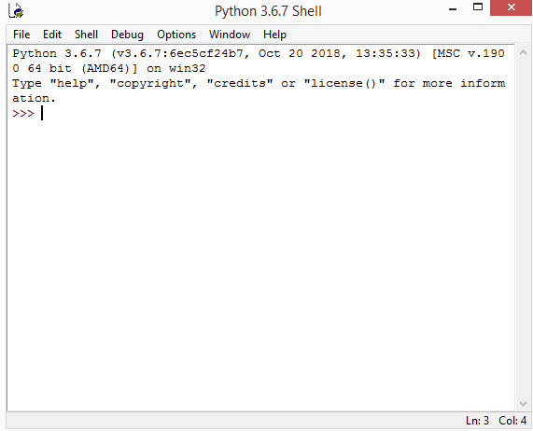

A File Editor
Every programmer needs to be able to edit and save text files. Python programs are files with the .py extension that contain lines of Python code. Python IDLE gives you the ability to create and edit these files with ease.
Python IDLE also provides several useful features that you’ll see in professional IDEs, like basic syntax highlighting, code completion, and auto-indentation. Professional IDEs are more robust pieces of software and they have a steep learning curve. If you’re just beginning your Python programming journey, then Python IDLE is a great alternative!
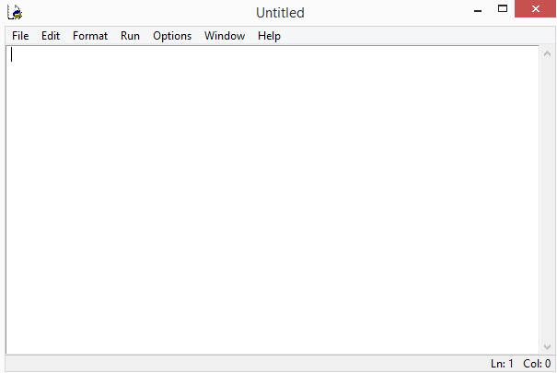

      - Functional Requirments&Non-functional Requirements
Functional Requirements
- Device must be enabled at all the condition.
- Device should be able to read the change in heart beat and temperature value accurately
- Device should be able to display the value of the sensor.
- Device should be able to capture the video and alert about the drowsiness.
- Device should send the message to the guardian about the condition and location of the person.

Non-Functional Requirements
The non-functional requirements are divided into usability, reliability, performance,
flexibility and safety.
USABILITY
The system must be easy to learn for both users of the device and helpers who are the using the device
RELIABILITY
The reliability of the device essentially depends on the software tools (Python IDLE, python, RPi-OS etc) and hardware tools (RaspberryPi, nodemcu heartbeat sensor etc.) used for the system development.
PERFORMANCE
- Heart beat and temperature data loading through the sensor from program measures accurately.
- Capturing the image frame and alerting of the drowsiness
- System will send a message to the guardian about the condition and location.

FLEXIBILITY
The system shall allow the system administrator to add additional features. The system needs to be cost-effective to maintain

SAFETY
In case of malfunction, system should shutdown itself and reboot in order to prevent unpredicted results.

3.2.2.2 User Requirements
<This template illustrates organizing the functional requirements for the product by system features, the major services provided by the product. You may prefer to organize this section by use case, mode of operation, user class, object class, functional hierarchy, or combinations of these, whatever makes the most logical sense for your product.>
REQ-1:
REQ-2:
:
REQ-N:
3.3 Summary

CHAPTER 4: DESIGN
4.1 Architectural Design

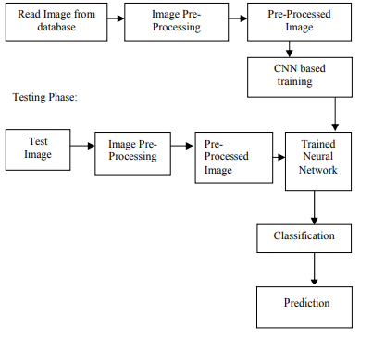

Fig: Architecture

4.2 Dataflow Diagram

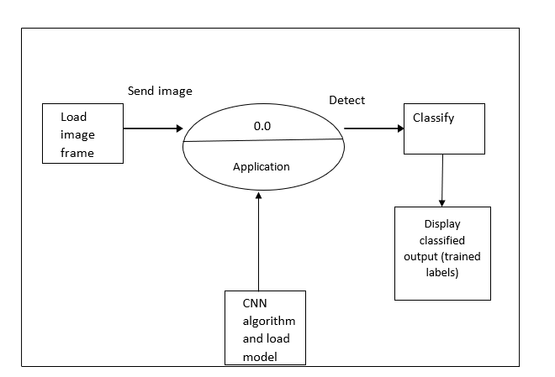
Fig: DATA FLOW DIAGRAM LEVEL 0
Above mentioned diagram is the representation of DFD0 which provides u the content diagram or say overview of the whole system. It is designed to be an at- a-glance view, showing the system as single high-level process. Here from the file image is be loaded to the application where the loaded frame is sent to classification unit to predict the result with the help of trained model file and output (trained labels).
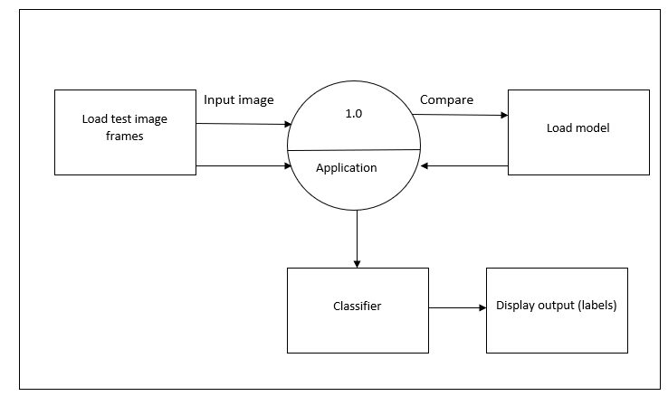
Fig: DFD Level 1
Above mentioned diagram is the representation of DFD1. The Level 0 DFD is broken down into more specific, Level 1 DFD. Level 1 DFD depicts basic modules in the system and flow of data among various modules. Here from the file image is be loaded to the application where the loaded image is sent to classification unit to predict the result and classes are classified for given label.

4.3 Class Hierarchy Diagram
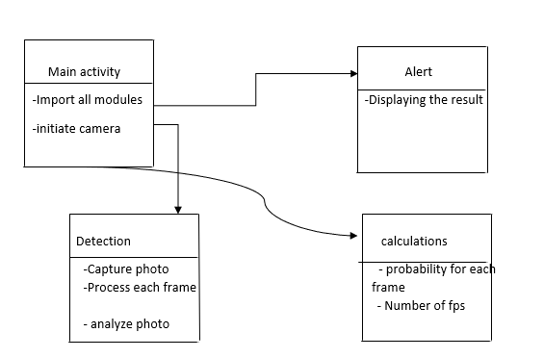
4.4 Usecase Diagrams
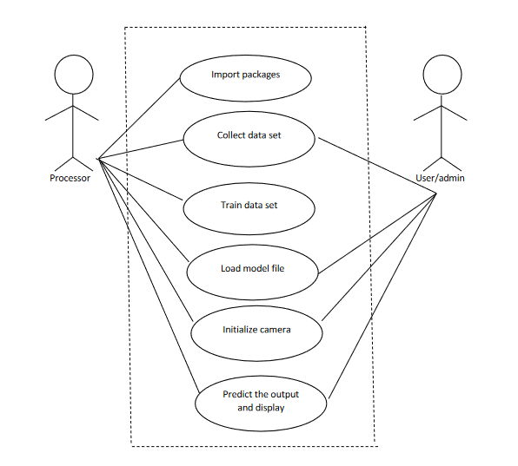
Fig: Use Case Diagram
Use case consists of user and processor where user is used to provide the input to the system and processor is used to process the input data and provide output. The flow is shown in the above diagram.
First user as to run the system and run the code, model and library packages are imported and loaded. After the run of code collect the drowsiness data, train and load model file. After all the functions, prediction and analysing the frame is performed and output is displayed

4.5 Sequence Diagrams
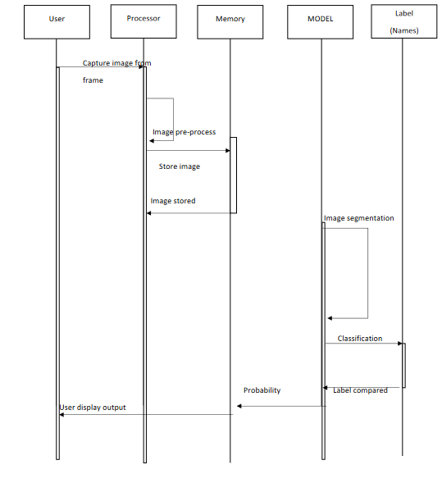
Sequence diagram consists of 5 different blocks namely user, processor, memory, Model and labels as shown in the above figure
User will provide the input image through the files already saved image is being taken in consideration which is been captured and sent to the processor where preprocessing of data is done which is resizing, reshaping and other parameters and after that those are stored in the memory unit.
After preprocessing and storing of image, trained model file is loaded where the featured of the image is extracted for classifying the output. After classifying the output, label is provided such as drinking water, normal and using mobile with the individual name.

4.5 Activity Diagram
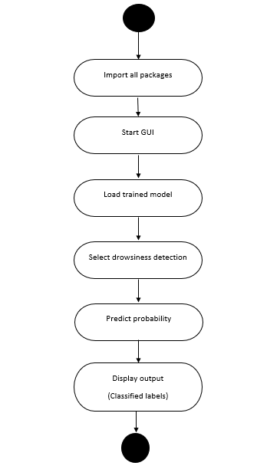

CHAPTER 5 : IMPLEMENTATION
Pixels: The Building Blocks of Images
Pixels are the raw building blocks of an image. Every image consists of a set of pixels. There is no finer granularity than the pixel. Normally, a pixel is considered the “color” or the “intensity” of light that appears in a given place in our image. If we think of an image as a grid, each square contains a single pixel. For example, take a look at Figure 3.1.
The image in Figure 3.1 above has a resolution of 1;000_750, meaning that it is 1;000 pixels wide and 750 pixels tall. We can conceptualize an image as a (multidimensional) matrix. In this case, our matrix has 1;000 columns (the width) with 750 rows (the height). Overall, there are
1;000_750 = 750;000 total pixels in our image.
Most pixels are represented in two ways:
1. Grayscale/single channel
2. Color
In a grayscale image, each pixel is a scalar value between 0 and 255, where zero corresponds to “black” and 255 being “white”. Values between 0 and 255 are varying shades of gray, where values closer to 0 are darker and values closer to 255 are lighter. The grayscale gradient image in
Figure 3.2 demonstrates darker pixels on the left-hand side and progressively lighter pixels on the right-hand side. Color pixels; however, are normally represented in the RGB color space.
Figure 3.1: This image is 1000 pixels wide and 750 pixels tall, for a total of 1000x750=750;000 total pixels.

Figure 3.2: Image gradient demonstrating pixel values going from black (0) to white (255).

Pixels in the RGB color space are no longer a scalar value like in a grayscale/single channel image – instead, the pixels are represented by a list of three values: one value for the Red component, one for Green, and another for Blue. To define a color in the RGB color model, all we need to do is define the amount of Red, Green, and Blue contained in a single pixel.
Each Red, Green, and Blue channel can have values defined in the range [0;255] for a total of 256 “shades”, where 0 indicates no representation and 255 demonstrates full representation. Given that the pixel value only needs to be in the range [0;255], we normally use 8-bit unsigned integers to represent the intensity. As we’ll see once we build our first neural network, we’ll often preprocess our image by performing mean subtraction or scaling, which will require us to convert the image to a floating point data type. Keep this point in mind as the data types used by libraries loading images from disk (such as OpenCV) will often need to be converted before we apply learning algorithms to the images directly. Given our three Red, Green, and Blue values, we can combine them into an RGB tuple in the form (red, green, blue). This tuple represents a given color in the RGB color space. The RGB color space is an example of an additive color space: the more of each color is added, the brighter the pixel becomes and closer to white. We can visualize the RGB color space in Figure 3.3 (left). As you can see, adding red and green leads to yellow. Adding red and blue yields pink. And adding all three red, green, and blue together, we create white.

Figure 3.3: Left: The RGB color space is additive. The more red, green and blue you mix together, the closer you get to white. Right: The RGB cube.
To make this example more concrete, let’s again consider the color “white” – we would fill each of the red, green, and blue buckets up completely, like this: (255, 255, 255). Then, to create the color black, we would empty each of the buckets out (0, 0, 0), as black is the absence of color.
To create a pure red color, we would fill up the red bucket (and only the red bucket) completely:
(255, 0, 0).
The RGB color space is also commonly visualized as a cube (Figure 3.3, right) Since an RGB color is defined as a 3-valued tuple, which each value in the range [0;255] we can thus think of the cube containing 256_256_256 = 16;777;216 possible colors, depending on how much Red,
Green, and Blue are placed into each bucket.
As an example, let’s consider how “much” red, green and blue we would need to create a single color (Figure 3.4, top). Here we set R=252, G=198, B=188 to create a color tone similar to the skin of a caucasian (perhaps useful when building an application to detect the amount of skin/flesh in an image). As we can see, the Red component is heavily represented with the bucket almost filled.
Green and Blue are represented almost equally. Combining these colors in an additive manner, we obtain a color tone similar to caucasian skin.
Figure 3.4: Top: An example of adding various Red, Green, and Blue color components together
to create a "caucasian flesh tone", perhaps useful in a skin detection program.

The Image Coordinate System As mentioned in Figure 3.1 earlier in this chapter, an image is represented as a grid of pixels. To make this point more clear, imagine our grid as a piece of graph paper. Using this graph paper, the origin point (0;0) corresponds to the upper-left corner of the image. As we move down and to the right, both the x and y values increase. Figure 3.6 provides a visual representation of this “graph paper” representation. Here we have the letter “I” on a piece of our graph paper. We see that this is an 8_8 grid with a total of 64 pixels.
It’s important to note that we are counting from zero rather than one. The Python language is zero indexed, meaning that we always start counting from zero.
Figure 3.6: The letter “I” placed on a piece of graph paper. Pixels are accessed by their (x;y)-
coordinates, where we go x columns to the right and y rows down, keeping in mind that Python is zero-indexed.

As an example of zero-indexing, consider the pixel 4 columns to the right and 5 rows down is indexed by the point (3;4), again keeping in mind that we are counting from zero rather than one.
Images as NumPy Arrays

Figure 3.7: Loading an image named example.png from disk and displaying it to our screen with
OpenCV.

Image processing libraries such as OpenCV and scikit-image represent RGB images as multidimensional NumPy arrays with shape (height, width, depth). Readers who are using image processing libraries for the first time are often confused by this representation – why does the height come before the width when we normally think of an image in terms of width first then height?
The answer is due to matrix notation.
When defining the dimensions of matrix, we always write it as rows x columns. The number
of rows in an image is its height whereas the number of columns is the image’s width. The depth
will still remain the depth.
Therefore, while it may be slightly confusing to see the .shape of a NumPy array represented
as (height, width, depth), this representation actually makes intuitive sense when considering
how a matrix is constructed and annotated.
RGB and BGR Ordering
It’s important to note that OpenCV stores RGB channels in reverse order. While we normally think
in terms of Red, Green, and Blue, OpenCV actually stores the pixel values in Blue, Green, Red
order.
Why does OpenCV do this? The answer is simply historical reasons. Early developers of the
OpenCV library chose the BGR color format because the BGR ordering was popular among camera manufacturers and other software developers at the time .
Simply put – this BGR ordering was made for historical reasons and a choice that we now have
to live with. It’s a small caveat, but an important one to keep in mind when working with OpenCV.
Scaling and Aspect Ratios
Scaling, or simply resizing, is the process of increasing or decreasing the size of an image in terms
of width and height. When resizing an image, it’s important to keep in mind the aspect ratio

image pre-processing pipeline that (1) loads an image from disk, (2)
resizes it to 32_32 pixels, (3) orders the channel dimensions, and (4) outputs the image.

THE FOUR STEPS TO CONSTRUCTING A DEEP LEARNING MODEL

Step #1: Gather Your Dataset
The first component of building a deep learning network is to gather our initial dataset. We need the images themselves as well as the labels associated with each image. These labels should come from a finite set of categories, such as: categories = dog, cat, panda.
Furthermore, the number of images for each category should be approximately uniform (i.e., the same number of examples per category). If we have twice the number of cat images than dog images, and five times the number of panda images than cat images, then our classifier will become naturally biased to overfitting into these heavily-represented categories.
Class imbalance is a common problem in machine learning and there exist a number of ways to overcome it. We’ll discuss some of these methods later, but keep in mind the best method to avoid learning problems due to class imbalance is to simply avoid class imbalance entirely.
Step #2: Split Your Dataset
Now that we have our initial dataset, we need to split it into two parts:
1. A training set
2. A testing set
A training set is used by our classifier to “learn” what each category looks like by making predictions on the input data and then correct itself when predictions are wrong. After the classifier has been trained, we can evaluate the performing on a testing set.
It’s extremely important that the training set and testing set are independent of each other and do not overlap! If you use your testing set as part of your training data, then your classifier has an unfair advantage since it has already seen the testing examples before and “learned” from them. Instead, you must keep this testing set entirely separate from your training process and use it only to evaluate your network.
Common split sizes for training and testing sets include 66:6%33:3%, 75%=25%, and 90%=10%, respectively. (Figure 4.7):
Figure 4.7: Examples of common training and testing data splits.

These data splits make sense, but what if you have parameters to tune? Neural networks have a number of knobs and levers (ex., learning rate, decay, regularization, etc.) that need to be tuned and dialed to obtain optimal performance. We’ll call these types of parameters hyperparameters, and it’s critical that they get set properly. In practice, we need to test a bunch of these hyperparameters and identify the set of parameters that works the best. You might be tempted to use your testing data to tweak these values, but again, this is a major no-no! The test set is only used in evaluating the performance of your network. Instead, you should create a third data split called the validation set. This set of the data (normally) comes from the training data and is used as “fake test data” so we can tune our hyperparameters. Only after have we determined the hyperparameter values using the validation set do we move on to collecting final accuracy results in the testing data. We normally allocate roughly 10-20% of the training data for validation. If splitting your data into chunks sounds complicrated, it’s actually not.
Step #3: Train Your Network
Given our training set of images, we can now train our network. The goal here is for our network to learn how to recognize each of the categories in our labeled data. When the model makes a mistake, it learns from this mistake and improves itself. So, how does the actual “learning” work? In general, we apply a form of gradient descent.
Step #4: Evaluate
Last, we need to evaluate our trained network. For each of the images in our testing set, we present them to the network and ask it to predict what it thinks the label of the image is. We then tabulate the predictions of the model for an image in the testing set.
Finally, these model predictions are compared to the ground-truth labels from our testing set. The ground-truth labels represent what the image category actually is. From there, we can compute the number of predictions our classifier got correct and compute aggregate reports such as precision, recall, and f-measure, which are used to quantify the performance of our network as a whole.

Convolutional Neural Networks
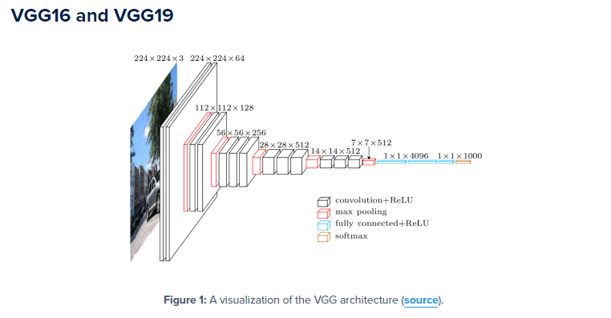
Each layer in a CNN applies a different set of filters, typically hundreds or thousands of them, and combines the results, feeding the output into the next layer in the network. During training, a
CNN automatically learns the values for these filters.
In the context of image classification, our CNN may learn to:
- Detect edges from raw pixel data in the first layer.
- Use these edges to detect shapes (i.e., “blobs”) in the second layer.
- Use these shapes to detect higher-level features such as facial structures, parts of a car, etc.in the highest layers of the network.
The last layer in a CNN uses these higher-level features to make predictions regarding the
Contents of the image.
In terms of deep learning, an (image) convolution is an element-wise multiplication of two matrices followed by a sum.
1. Take two matrices (which both have the same dimensions).
2. Multiply them, element-by-element (i.e., not the dot product, just a simple multiplication).
3. Sum the elements together.
Kernels
Again, let’s think of an image as a big matrix and a kernel as a tiny matrix (at least in respect to the
original “big matrix” image), depicted in Figure 11.1. As the figure demonstrates, we are sliding
the kernel (red region) from left-to-right and top-to-bottom along the original image. At each
(x;y)-coordinate of the original image, we stop and examine the neighborhood of pixels located at
the center of the image kernel. We then take this neighborhood of pixels, convolve them with the
kernel, and obtain a single output value. The output value is stored in the output image at the same
(x;y)-coordinates as the center of the kernel.
If this sounds confusing, no worries, we’ll be reviewing an example in the next section. But
before we dive into an example, let’s take a look at what a kernel looks like (Figure 11.3):
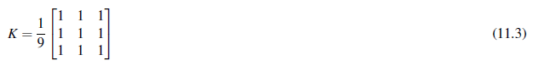

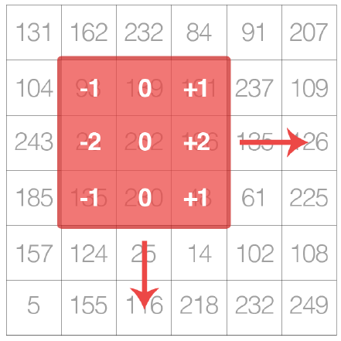
Figure 11.1: A kernel can be visualized as a small matrix that slides across, from left-to-right and
top-to-bottom, of a larger image. At each pixel in the input image, the neighborhood of the image
is convolved with the kernel and the output stored.

We use an odd kernel size to ensure there is a valid integer (x;y)-coordinate at the center of
the image (Figure 11.2). On the left, we have a 3_3 matrix. The center of the matrix is located at
x = 1;y = 1 where the top-left corner of the matrix is used as the origin and our coordinates are
zero-indexed. But on the right, we have a 2_2 matrix. The center of this matrix would be located
at x = 0:5;y = 0:5.
But as we know, without applying interpolation, there is no such thing as pixel location
(0:5;0:5) – our pixel coordinates must be integers! This reasoning is exactly why we use odd kernel
sizes: to always ensure there is a valid (x;y)-coordinate at the center of the kernel.

Example of Convolution
Now that we have discussed the basics of kernels, let’s discuss the actual convolution operation and
see an example of it actually being applied to help us solidify our knowledge. In image processing,
a convolution requires three components:
1. An input image.
2. A kernel matrix that we are going to apply to the input image.
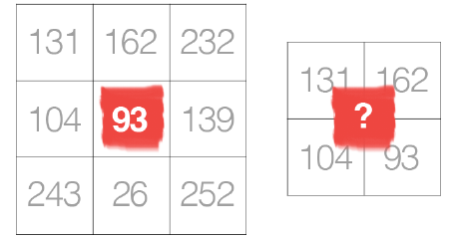
Figure 11.2: Left: The center pixel of a 3_3 kernel is located at coordinate (1;1) (highlighted in
red). Right: What is the center coordinate of a kernel of size 2_2?
3. An output image to store the output of the image convolved with the kernel.
Convolution (i.e., cross-correlation) is actually very easy. All we need to do is:
1. Select an (x;y)-coordinate from the original image.
2. Place the center of the kernel at this (x;y)-coordinate.
3. Take the element-wise multiplication of the input image region and the kernel, then sum
up the values of these multiplication operations into a single value. The sum of these
multiplications is called the kernel output.
4. Use the same (x;y)-coordinates from Step #1, but this time, store the kernel output at the
same (x;y)-location as the output image.
Below you can find an example of convolving (denoted mathematically as the ? operator) a
3_3 region of an image with a 3_3 kernel used for blurring:
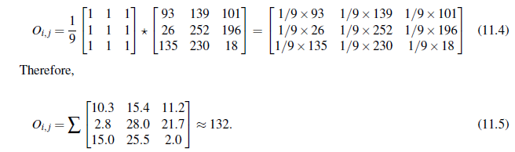
After applying this convolution, we would set the pixel located at the coordinate (i; j) of the
output image O to Oi; j = 132.
That’s all there is to it! Convolution is simply the sum of element-wise matrix multiplication
between the kernel and neighborhood that the kernel covers of the input image.
Layer Types

There are many types of layers used to build Convolutional Neural Networks, but the ones you are most likely to encounter include:
- Convolutional (CONV)
- Activation (ACT or RELU, where we use the same of the actual activation function)
- Pooling (POOL)
- Fully-connected (FC)
- Batch normalization (BN)
- Dropout (DO)

Stacking a series of these layers in a specific manner yields a CNN. We often use simple text diagrams to describe a CNN: INPUT => CONV => RELU => FC => SOFTMAX
Here we define a simple CNN that accepts an input, applies a convolution layer, then an activation layer, then a fully-connected layer, and, finally, a softmax classifier to obtain the output classification probabilities. The SOFTMAX activation layer is often omitted from the network diagram as it is assumed it directly follows the final FC.
Of these layer types, CONV and FC, (and to a lesser extent, BN) are the only layers that contain parameters that are learned during the training process. Activation and dropout layers are not considered true “layers" themselves, but are often included in network diagrams to make the architecture explicitly clear. Pooling layers (POOL), of equal importance as CONV and FC, are also included in network diagrams as they have a substantial impact on the spatial dimensions of an image as it moves through a CNN.
CONV, POOL, RELU, and FC are the most important when defining your actual network architecture. That’s not to say that the other layers are not critical, but take a backseat to this critical set of four as they define the actual architecture itself.

NOTE:Activation functions themselves are practically assumed to be part of the architecture, When defining CNN architectures we often omit the activation layers from a table/diagram to save space; however, the activation layers are implicitly assumed to be part of the architecture.
In the remainder of this section, we’ll review each of these layer types in detail and discuss the parameters associated with each layer (and how to set them). Later in this chapter I’ll discuss in more detail how to stack these layers properly to build your own CNN architectures.

Convolutional Layers
The CONV layer is the core building block of a Convolutional Neural Network. The CONV layer parameters consist of a set of K learnable filters (i.e., “kernels”), where each filter has a width and a height, and are nearly always square. These filters are small (in terms of their spatial dimensions) but extend throughout the full depth of the volume.
For inputs to the CNN, the depth is the number of channels in the image (i.e., a depth of three when working with RGB images, one for each channel). For volumes deeper in the network, the depth will be the number of filters applied in the previous layer. To make this concept more clear, let’s consider the forward-pass of a CNN, where we convolve each of the K filters across the width and height of the input volume, just like we did in Section
11.1.5 above. More simply, we can think of each of our K kernels sliding across the input region,
computing an element-wise multiplication, summing, and then storing the output value in a 2-
dimensional activation map, such as in Figure 11.6.

Figure 11.6: Left: At each convolutional layer in a CNN, there are K kernels applied to the input
volume. Middle: Each of the K kernels is convolved with the input volume. Right: Each kernel
produces an 2D output, called an activation map.

After applying all K filters to the input volume, we now have K, 2-dimensional activation maps.
We then stack our K activation maps along the depth dimension of our array to form the final output
volume (Figure 11.7).
Figure 11.7: After obtaining the K activation maps, they are stacked together to form the input
volume to the next layer in the network.

Every entry in the output volume is thus an output of a neuron that “looks” at only a small region of the input. In this manner, the network “learns” filters that activate when they see a specific type of feature at a given spatial location in the input volume. In lower layers of the network, filters may activate when they see edge-like or corner-like regions.
Then, in the deeper layers of the network, filters may activate in the presence of high-level features, such as parts of the face, the paw of a dog, the hood of a car, etc. This activation concept goes back to our neural network analogy in Chapter 10 – these neurons are becoming “excited” and “activating” when they see a particular pattern in an input image.

The concept of convolving a small filter with a large(r) input volume has special meaning in
Convolutional Neural Networks – specifically, the local connectivity and the receptive field of
a neuron. When working with images, it’s often impractical to connect neurons in the current volume to all neurons in the previous volume – there are simply too many connections and too many weights, making it impossible to train deep networks on images with large spatial dimensions.
Instead, when utilizing CNNs, we choose to connect each neuron to only a local region of the input volume – we call the size of this local region the receptive field (or simply, the variable F) of the neuron.
To make this point clear, let’s return to our CIFAR-10 dataset where the input volume as an input size of 32_32_3. Each image thus has a width of 32 pixels, a height of 32 pixels, and a depth of 3 (one for each RGB channel). If our receptive field is of size 3_3, then each neuron in the CONV layer will connect to a 3_3 local region of the image for a total of 3_3_3 = 27 weights (remember, the depth of the filters is three because they extend through the full depth of the input image, in this case, three channels).
Now, let’s assume that the spatial dimensions of our input volume have been reduced to a smaller size, but our depth is now larger, due to utilizing more filters deeper in the network, such that the volume size is now 16_16_94. Again, if we assume a receptive field of size 3_3, then every neuron in the CONV layer will have a total of 3_3_94=846 connections to the input volume.
Simply put, the receptive field F is the size of the filter, yielding an F _F kernel that is convolved with the input volume.
At this point we have explained the connectivity of neurons in the input volume, but not the arrangement or size of the output volume. There are three parameters that control the size of an output volume: the depth, stride, and zero-padding size, each of which we’ll review below.
Depth
The depth of an output volume controls the number of neurons (i.e., filters) in the CONV layer that connect to a local region of the input volume. Each filter produces an activation map that “activate” in the presence of oriented edges or blobs or color.
For a given CONV layer, the depth of the activation map will be K, or simply the number of
filters we are learning in the current layer. The set of filters that are “looking at” the same (x;y)
location of the input is called the depth column.
Zero-padding
As we know from Section 11.1.5, we need to “pad” the borders of an image to retain the original
image size when applying a convolution – the same is true for filters inside of a CNN. Using
zero-padding, we can “pad” our input along the borders such that our output volume size matches
our input volume size. The amount of padding we apply is controlled by the parameter P.
This technique is especially critical when we start looking at deep CNN architectures that apply
multiple CONV filters on top of each other. To visualize zero-padding, again refer to Table 11.1
where we applied a 3_3 Laplacian kernel to a 5_5 input image with a stride of S = 1.
We can see in Table 11.3 (left) how the output volume is smaller (3_3) than the input volume
(5_5) due to the nature of the convolution operation. If we instead set P = 1, we can pad our input
volume with zeros (middle) to create a 7_7 volume and then apply the convolution operation,
leading to an output volume size that matches the original input volume size of 5_5 (right).
Without zero padding, the spatial dimensions of the input volume would decrease too quickly,
and we wouldn’t be able to train deep networks (as the input volumes would be too tiny to learn
any useful patterns from).
Putting all these parameters together, we can compute the size of an output volume as a function
of the input volume size (W, assuming the input images are square, which they nearly always are),
the receptive field size F, the stride S, and the amount of zero-padding P. To construct a valid CONV
Activation Layers
After each CONV layer in a CNN, we apply a nonlinear activation function, such as ReLU, ELU, or
any of the other Leaky ReLU variants mentioned in Chapter 10. We typically denote activation
layers as RELU in network diagrams as since ReLU activations are most commonly used, we may
also simply state ACT – in either case, we are making it clear that an activation function is being
applied inside the network architecture.
Activation layers are not technically “layers” (due to the fact that no parameters/weights are
learned inside an activation layer) and are sometimes omitted from network architecture diagrams
as it’s assumed that an activation immediately follows a convolution.
In this case, authors of publications will mention which activation function they are using
after each CONV layer somewhere in their paper. As an example, consider the following network
architecture: INPUT => CONV => RELU => FC.
To make this diagram more concise, we could simply remove the RELU component since it’s
assumed that an activation always follows a convolution: INPUT => CONV => FC. I personally do
not like this and choose to explicitly include the activation layer in a network diagram to make it
clear when and what activation function I am applying in the network.
An activation layer accepts an input volume of sizeWinput _Hinput _Dinput and then applies the
given activation function (Figure 11.9). Since the activation function is applied in an element-wise
manner, the output of an activation layer is always the same as the input dimension,Winput =Wout put ,
Hinput = Hout put , Dinput = Dout put .

Pooling Layers

There are two methods to reduce the size of an input volume – CONV layers with a stride > 1 (which
we’ve already seen) and POOL layers. It is common to insert POOL layers in-between consecutive
Figure 11.9: An example of an input volume going through a ReLU activation, max(0;x). Activations
are done in-place so there is no need to create a separate output volume although it is easy to
visualize the flow of the network in this manner.

CONV layers in a CNN architectures:
INPUT => CONV => RELU => POOL => CONV => RELU => POOL => FC

The primary function of the POOL layer is to progressively reduce the spatial size (i.e., width
and height) of the input volume. Doing this allows us to reduce the amount of parameters and
computation in the network – pooling also helps us control overfitting.
POOL layers operate on each of the depth slices of an input independently using either the
max or average function. Max pooling is typically done in the middle of the CNN architecture
to reduce spatial size, whereas average pooling is normally used as the final layer of the network

(e.x., GoogLeNet, SqueezeNet, ResNet) where we wish to avoid using FC layers entirely. The most
common type of POOL layer is max pooling, although this trend is changing with the introduction
of more exotic micro-architectures.
Typically we’ll use a pool size of 2_2, although deeper CNNs that use larger input images
(> 200 pixels) may use a 3_3 pool size early in the network architecture. We also commonly set
the stride to either S = 1 or S = 2. Figure 11.10 (heavily inspired by Karpathy et al. [121]) follows
an example of applying max pooling with 2_2 pool size and a stride of S = 1. Notice for every
2_2 block, we keep only the largest value, take a single step (like a sliding window), and apply
the operation again – thus producing an output volume size of 3_3.
We can further decrease the size of our output volume by increasing the stride – here we apply
S = 2 to the same input (Figure 11.10, bottom). For every 2_2 block in the input, we keep only
the largest value, then take a step of two pixels, and apply the operation again. This pooling allows
us to reduce the width and height by a factor of two, effectively discarding 75% of activations from
the previous layer.
In summary, POOL layers Accept an input volume of size Winput _Hinput _Dinput . They then
require two parameters:
- The receptive field size F (also called the “pool size”).
- The stride S.
Applying the POOL operation yields an output volume of sizeWout put _Hout put _Dout put , where:
- Wout put = ((Winput 􀀀F)=S)+1
- Hout put = ((Hinput 􀀀F)=S)+1
- Dout put = Dinput
In practice, we tend to see two types of max pooling variations:
_ Type #1: F = 3;S = 2 which is called overlapping pooling and normally applied to images/
input volumes with large spatial dimensions.

Figure 11.10: Left: Our input 4_4 volume. Right: Applying 2_2 max pooling with a stride of
S = 1. Bottom: Applying 2_2 max pooling with S = 2 – this dramatically reduces the spatial
dimensions of our input.

Fully-connected Layers
Neurons in FC layers are fully-connected to all activations in the previous layer, as is the standard for feedforward neural networks that we’ve been discussing in Chapter 10. FC layers are always placed at the end of the network (i.e., we don’t apply a CONV layer, then an FC layer, followed by another CONV) layer. It’s common to use one or two FC layers prior to applying the softmax classifier, as the following (simplified) architecture demonstrates:

INPUT => CONV => RELU => POOL => CONV => RELU => POOL => FC => FC
Here we apply two fully-connected layers before our (implied) softmax classifier which will compute our final output probabilities for each class.

Batch Normalization
First introduced by Ioffe and Szgedy in their 2015 paper, Batch Normalization: Accelerating Deep Network Training by Reducing Internal Covariate Shift [123], batch normalization layers (or BN for short), as the name suggests, are used to normalize the activations of a given input volume before passing it into the next layer in the network. If we consider x to be our mini-batch of activations, then we can compute the normalized ˆ x via the following equation

We set e equal to a small positive value such as 1e-7 to avoid taking the square root of zero.
Applying this equation implies that the activations leaving a batch normalization layer will have approximately zero mean and unit variance (i.e., zero-centered).
At testing time, we replace the mini-batch mb and sb with running averages of mb and sb computed during the training process. This ensures that we can pass images through our network and still obtain accurate predictions without being biased by the mb and sb from the final mini-batch passed through the network at training time. Batch normalization has been shown to be extremely effective at reducing the number of epochs it takes to train a neural network. Batch normalization also has the added benefit of helping “stabilize” training, allowing for a larger variety of learning rates and regularization strengths. Using batch normalization doesn’t alleviate the need to tune these parameters of course, but it will make your life easier by making learning rate and regularization less volatile and more straightforward to tune. You’ll also tend to notice lower final loss and a more stable loss curve when using batch normalization in your networks.
The biggest drawback of batch normalization is that it can actually slow down the wall time it takes to train your network (even though you’ll need fewer epochs to obtain reasonable accuracy) by 2-3x due to the computation of per-batch statistics and normalization.
That said, I recommend using batch normalization in nearly every situation as it does make a significant difference. As we’ll see later in this book, applying batch normalization to our network architectures can help us prevent overfitting and allows us to obtain significantly higher classification accuracy in fewer epochs compared to the same network architecture without batch normalization.

Dropout
The last layer type we are going to discuss is dropout. Dropout is actually a form of regularization that aims to help prevent overfitting by increasing testing accuracy, perhaps at the expense of training accuracy. For each mini-batch in our training set, dropout layers, with probability p, randomly disconnect inputs from the preceding layer to the next layer in the network architecture.
Figure 11.11 visualizes this concept where we randomly disconnect with probability p=0:5 the connections between two FC layers for a given mini-batch. Again, notice how half of the connections are severed for this mini-batch. After the forward and backward pass are computed for the minibatch, we re-connect the dropped connections, and then sample another set of connections to drop.
The reason we apply dropout is to reduce overfitting by explicitly altering the network architecture at training time. Randomly dropping connections ensures that no single node in the network is responsible for “activating” when presented with a given pattern. Instead, dropout ensures there are multiple, redundant nodes that will activate when presented with similar inputs – this in turn helps our model to generalize.
It is most common to place dropout layers with p = 0:5 in-between FC layers of an architecture
where the final FC layer is assumed to be our softmax classifier:
Serializing a Model to Disk
Using the Keras library, model serialization is as simple as calling model.save on a trained model
and then loading it via the load_model function.

The LeNet Architecture
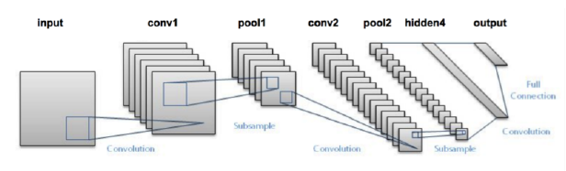
Figure 14.1: The LeNet architecture consists of two series of CONV => TANH => POOL layer sets
followed by a fully-connected layer and softmax output.

REFERENCES
Space for link to base papers
[1] yang xing, chen lv, juaji wang, dongpu cao, efstath iosvelenis, fei - yue wang, “driver activity recognition for intelligent vehicles: a deep learning approach”, ieee transactions on vehicular technology, vol. 68, no. 68, 6 june 2019.
[2] kevan yuen, mohan trivedi, “looking at hands in autonomous vehicles: a convnet approach using part affinity fields.”, ieee transaction on intelligent vehicles, 2019.
[3]ahmed youssef, jean - marieaerts, bartsvanrumste, stijn luca, “a localized learning approach applied to human activity recognition”, ieee intelligent systems, ieee (early access), 2020.
[4] felix - constantinadochieei, ioana raluca adochiei, radu ciucu, gladiola pietroiu - andruseac, florin ciprianargatu, nicole jula, “design and implementation of a body posture detection system”, 2019 e - health and bio – engineering conference (ehb), lasi, romania, 2019, pp.1 - 4.
[5] yukun zheng, hongxiang yuan, rui song, xin ma, yibin li, “a comparative study of hand gestures recognition based on mobilenetv2 and convnet models.”, ieee international conference on image and signal processing and their applications, 2019, pp. 1 - 6.

GUIDELINES FOR PROJECT WORK-II REPORT WRITING

1 ORGANIZATION OF THE REPORT: Size of report shall be of minimum 20 pages. The report shall be presented in different chapters introduction and Literature survey. Each of the chapters should be given precise title reflecting the contents of that chapter. A chapter can be divided and subdivided into sections and subsections so as to present the content discretely and with due emphasis. In addition to main material of the report; preliminaries, references, appendices etc should be included in the report.
1.1. Sequence of Contents: The material should be placed and bound in following order:
i) Preliminaries: The following information should be furnished in the given sequence.
Top Sheet of transparent plastic
Title page
Certificate
Declaration
Acknowledgement
Abstract
Table of Contents

ii) The Chapters (Main material):
It shall be presented in number of chapter’s introduction and Literature survey
iii) References:

2 PRELIMINARIES:
2.1. Title Page: It is a first page of report. Try to find a title that clearly describes the work you have done and be as precise as possible. Mention Project Work-I, your name, guide’s (and co-guide’s) name, name of the department (i.e. Computer Science and Engineering etc), name of the institute, place, month and year of the submission of report.
2.2. Abstract: This is the summary of your work i.e. Project Work-I ,Summarize the main points of the report separately on one page. Interested persons should be able to judge from the abstract whether the report is really interesting for them. So, briefly formulate your work that has been implemented, the solutions derived, the results that have been achieved, and your conclusions. The abstract should not occupy more than one page (about 150 to 250 words). It must contain the context/ relevance of your idea or implementation or study at hand, a description of what was done and a gist of the significant studies, observations. It’s noteworthy that the abstract shall be prepared after project work is over and report is completed in all respect. This page should precede the ToC page.
2.3 Certificate and Declaration: Both pages shall be in the unique format provided with this report writing manual and duly signed by student, guide and all the authorities in relation to your work with date.
2.4 Acknowledgement: here you have to acknowledge all the personalities who helped
you in your work. Please keep this brief . Do include all those who helped you,
e.g. other faculty / staff you consulted, colleagues who assisted etc.

2.5 Table of Contents (ToC):
- It should list items in the following order.
- Certificate (before ToC)
- Declaration (before ToC)
- Acknowledgement
- Abstract (before ToC)
- The chapters (1, 2, … N, followed by the name of the chapter),
- Sections within chapters (e.g. 1.1, 2.4, etc. + name)
- Subsections within sections (e.g. 1.1.1 + name)
- References
- Do not include the table of contents itself in the ToC.
- Use borderless table for ToC

2.6 Numbering of Report: Every page of the report other than the title page should be numbered. Pages of Certificate, Declaration ,Acknowledgement, Abstract Table of Contents should be numbered with lower case Roman numerals (i, ii, iii, iv, …etc.). From the first page of the first chapter onwards, all the pages should be numbered using numerals (1, 2, 3, … etc.). The page numbers should appear at the bottom center as it is appearing in this document.

3 THE CHAPTERS: In general the following chapters may be included

Introduction.
Literature survey.

you have to structure report according to the flow of overall logic of your work.

3.1 General Guidelines:
- Each chapter, section, subsection, etc. should have a title. An identical entry should exist in the ToC. Each chapter is numbered using numerals: 1, 2, 3, ..
- Title with interrogative sentence should be avoided.
- The chapters may be structured in to sections and subsections. Sections within a chapter are numbered using a two-level numbering scheme, (chapter no).(section no); for example, sections in chapter 3 are numbered 3.1, 3.2, ... Subsections within a section are numbered using a three-level scheme, (chapter no).(section no).(subsection no); for example, subsections in chapter 3, section 2 are numbered 3.2.1, 3.2.2, ... The sections and sub-sections must carry titles. Use different fonts for section titles and sub-section titles as specified in section 7.3.2 on page no 7.

3.2 Introduction: In this chapter give introductory information about your project work I. The purpose of this section is to let reader know briefly about your work. Apart from introduction mention about need of taking this work, problem that you want to address, the statement of a problem and its relevance, the initial goals you had, etc. without going into details. Here you also describe the structure of the rest of your report, indicating which chapter will address which issue.

3.3 Literature Survey: While implementing any new idea or delivering a seminar on new technology, there is need to refer previous technical material available on this issue. you have to read books or technical papers available on your topic or idea. Referring the technical material related to your topic you have to do literature survey. It should be as exhaustive as possible but related to your work. The discussion on the literature may be organized under a separate heading & titled suitably. Summarize the literature that you have read. Rather than literally copying the texts that you have read, you should present your own interpretation of the theory. This will help you in developing your own thinking discipline and technical language. The last part of this section must contain a brief mention of the gaps in the literature and a justification for undertaking your seminar/minor project. Do not be too general. Avoid writing essays on historical developments.

4 REFERENCES: This chapter is also referred as “Literature used”. Each entry in the reference has a label. All references cited in the text-body should be there in the Reference list and vice versa. Established acronyms may be used. e.g. AC, DC, ASME, ASTM, IIT, Jnl, etc., provided there is no likelihood of any confusion.
- Labeling: One of the following systems can be used for labeling the cited entries.
System 1: A numeric label arranged in an order of citation in the main text. This label is used in square brackets or as superscript at the point of citation, e.g. [34]. The references should be arranged together in the order of this numeric label.
System 2: A label derived from the authors name and the year of publication. For entries with 2 authors, include the surnames of both the authors followed by the year of publication. For entries with multiple authors, include the surnames of the first author followed by ‘et al.’ and the year of publication. This label is used in round brackets at the point of citation, e.g. (Taylor, 1982) or (Taylor et al., 1982) or (Taylor and Morgan, 1982).
- The references should be arranged together in the alphabetical order of the author surname (1st priority) and the year of publication (2nd priority).
- The reference list thus compiled together should be included after Appendices. In the reference list, you should provide the details of each entry in the following manner. These details differ depending on the type of bibliographic entry.
- For a book: name of the authors, title, publisher, city of publication and year of publication, page numbers. (Taylor J. R., An Introduction to Error Analysis, Oxford University Press, Mill Valley, CA,USA, 1982, pp. 34-67)
- For an article in a journal: name of the authors, title, name of the journal, volume (issue number), year and range of pages. (Bandyopadhyay S., Bera N.C. and Bhattacharyya S., ‘Thermoeconomic Optimization of Combined Cycle Power Plants’, Energy Conver. Mgmt., 42(3), 2001, pp. 34-67)
- For an article in conference proceedings: name of the authors, title, name of conference, editors (if present), year range of pages. (Kedare S.B. ‘Optics, Design, Performance and Economics of the Dynamic Fresnel Paraboloid Reflector Concentrator Dish with Point Focus for High Temperature Solar Thermal Applications’, Proceedings of National Renewable Energy Convention ’99, Sawhney R.L. (Ed.), 1999, pp. 34-67.)
- A chapter in a book: authors of the chapter, title of the chapter, editors of the book, title of the book, publisher, city of publication, year of publication and range of pages.(Bilgen E., Industrial Solar Power Stations, Veziroglu T.N. (Ed.), Solar Energy and Conservation: Technology, Commercialization, Utilization, Volume2, Pergamon Press, NY, USA,1978, pp. 34-67)
- A report: authors, title, university/company, report number, year. (Ahmed K., Renewable Energy Technologies, World Bank Technical Paper Number 240, 1994)
- A Ph.D. or Masters Thesis: author, title, department, university, year. (Kedare S.B.,
'Investigations on a Reciprocating Wind Machine', Ph.D. Thesis, Dept. of Mechanical Engineering, IIT, Mumbai, 1991)
- A manual / handbook / standards : company name (if there are no authors), title, reference number, year. (British Standards Institution, Specification for Steel girder bridges, BS153 : Parts 3B & 4 : 1972, 1972)
- A web-site : Author or Organization, name of the site, complete address of the site, date visited (Danish Wind Industry Association, Aerodynamics of Wind Turbines: Lift, http://www.windpower.org /tour/wtrb/lift.htm, Aug 16, 2002)
- Bibliography: In a few exceptional cases, it is useful to suggest a list of publications for background reading. These are not cited anywhere in the text. This list can be included as ‘Bibliography’. It should follow ‘References’ on a fresh page.

5 ADDITIONAL GUIDELINES FOR PROJECT Work-II REPORT: Following are the additional important guidelines which shall be followed by all students.
5.1 Interaction With Guide: It is recommended that you meet your guide regularly during the course of the seminar/project. You should maintain a record notebook/file where you can include a record of your discussions with your guide, literature survey details, derivations etc. Such a system will allow easy and quick access to the details and chronology of your work. The final responsibility for producing an error-free report lies with student.
5.2 Submission: Before the end of semester, student shall deliver a seminar and submit the seminar report
Students shall follow the following guidelines for final submission.
- First, get draft copy of your report approved and certified by your guide.
- Submit two copies per group for project work-I (Guide and department)
- The bound copies of your report should be submitted within the given deadline. Late submission may not be acceptable. Make sure that the certificate in your report is signed by concerned authorities before you make the final submission of the report.
5.2.1 Binding: The report shall be Soft bound.
6. Format:
6.1 Paper : use plain A4 sized (height 297 mm, width 210 mm) good photocopying paper sheets, 70 to 90 gsm (16 to 20 pounds), whiteness 95% or above, smooth finish.
6.2 Typesetting, Text Processing and Printing:
- All material should be typed in 1.5 line spacing using times new roman and the vertical space between paragraphs shall be 2.5 line spacing. The first line of each paragraph should normally be indented by six characters.
- The recommended margins are 25 mm (1 inch) for top, bottom, right and left with an extra 13 mm (0.5 inch) for binding on the left. Other than page numbers, no material should intrude into these margins.
- Headings. Headings should be capitalized (i.e., nouns, verbs, and all other words except articles, prepositions, and conjunctions should be set with an initial capital) and should, with the exception of the Chapter title, be aligned to the left. Only the first two levels of section headings should be numbered, as shown in Table 1. The respective font sizes are also given in Table 1. Kindly refrain from using “0” when numbering your section headings.

- Table 1. Font sizes of headings. Table captions should always be positioned above the tables.
Heading level | Example | Font size and style
Heading level 1 (centered) | INTRODUCTİON | 16 point, bold
Heading level 2 | 1.1 Background | 14 point, bold
Heading level 3 | 1.1.1 History | 12 point, bold
- All the Contents should be in Times New Roman and Font Size 12
.
6.3 General Guidelines
- Do not make spelling or grammatical mistakes in your report.
- Use the passive voice ("was done") in technical writing.
- A paragraph should normally comprise of more than one line.
- Only one line of any paragraph should not be left at the top or bottom of the page.
- Pay attention to detail and accuracy.
- Be clear, but concise.
- Sincerely avoid typographical errors. Remember, these mistakes will result in a re-submission.
- Read report carefully before submission
Project Co-Ordinators: HOD(CSE)
Ramya Srikanteswara, Jagadevi N Kalshetty, Ushashree P

